<Online Learning Platform>

Use-Case Specification: <Take quiz>

Version <1.0>

Revision History

| **Date** | **Version** | **Description** | **Author** |
| --- | --- | --- | --- |
| <10/Dec/2021> | <1.0> | <Initial version> | <Nguyễn Tuấn Nghĩa> |
|  |  |  |  |
|  |  |  |  |
|  |  |  |  |

Table of Contents

1. Use-Case Name 3

1.1 Brief Description

2. Flow of Events 3

2.1 Basic Flow 3

2.2 Alternative Flows 3

2.2.1 < First Alternative Flow > 3

2.2.2 < Second Alternative Flow > 3

3. Special Requirements 3

3.1 < First Special Requirement > 3

4. Preconditions 3

4.1 < Precondition One > 3

5. Postconditions 3

5.1 < Postcondition One > 3

6. Extension Points 3

6.1 <Name of Extension Point> 3

Use-Case Specification: <Take Quiz>

# Use-Case Name

## Brief Description

* This use case allows user to take quizzes
* Subject: Enrolled student
* Purpose: Help students to complete their quizzes with ease

# Flow of Events

## Basic Flow

First, student clicks on 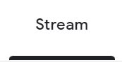 (STREAM), this will lead the user to the stream of the class. In this page students can see topics which have been uploaded by the teacher. User click on  (OPEN) button on top right of the topic in order to access the quiz. This will bring the student to a new page where the student will need to click on the quiz title in the middle of the page to access the quiz.

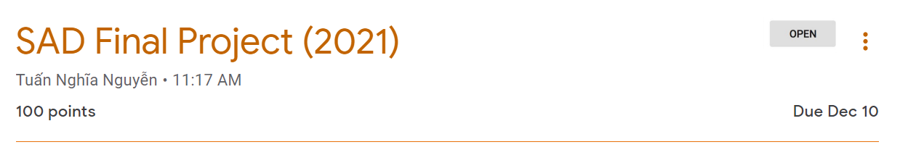

Types of quiz:

* Multiple Choice Question:

+ Student needs to click on one circle in which student think that it is the correct one  after being clicked the box turn green . Students are allowed to choose ONLY ONE answer, if a student chooses a new answer, the new answer will show a green box and the old green box will disappear.

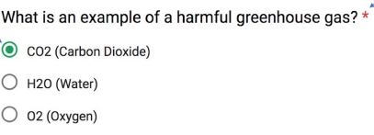

* Short/Long Answer Question:

+ Student click on the text and type their answer

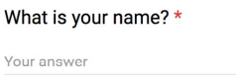

* Checkbox Question:

+ Students can click on many boxes  after being clicked the box turn green . Students click on as many answers as they want.

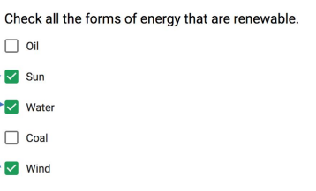

* Dropbox Question:

+ Click on  (CHOOSE) button, a dropdown menu will appear, click on the correct answer

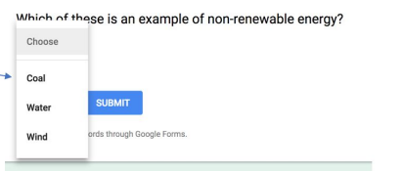

* File Upload Question

+ Click on  (ADD FILE) button, students choose file to upload from local computer

* Linear Scale Question

+ Click on the number that corresponds best to what student want

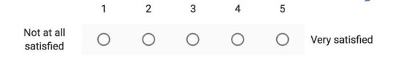

* Date and Time Question

+ Type in correct form of date and time to answer the question

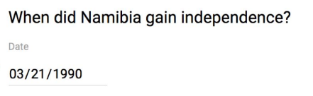

After finishing the quiz students click (TURN IN) 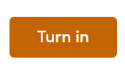 Button to submit their file. After successfully submitted the (TURN IN) button turn to (TURNED IN) .

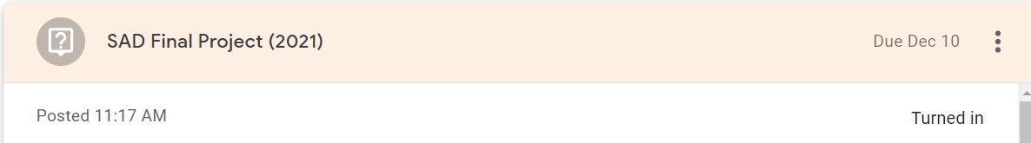

## Alternative Flows

# Special Requirements

# Preconditions

# Postconditions

# Prototype



**